[](https://www.festivaloflearning.org.uk/)

[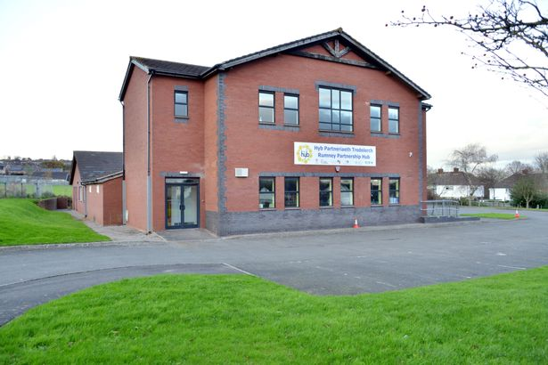](http://www.google.co.uk/url?sa=i&rct=j&q=&esrc=s&source=images&cd=&cad=rja&uact=8&ved=0ahUKEwjx2-Km66TNAhXKIMAKHY-BAwUQjRwIBw&url=http://www.walesonline.co.uk/news/wales-news/cardiffs-first-community-partnership-hub-10482460&bvm=bv.124272578,d.ZGg&psig=AFQjCNFwt0SbnfJ_tBAhb7XCCzn_v_b6Aw&ust=1465901619520094)

Adult Learning Celebration

Rumney Partnership Hub

Thursday 30th June 10-1pm

Come and join us and to take part in tasters/activities, we will be offering Cake Decorating, Jewellery Making, Gardening taster session, Ipad session and more.

[](http://www.google.co.uk/url?sa=i&rct=j&q=&esrc=s&source=images&cd=&cad=rja&uact=8&ved=0ahUKEwj5ju_F6qTNAhUoAcAKHbxQB14QjRwIBw&url=http://www.hotcourses.com/courses/greater-london/cake-decorating-classes/17323/&bvm=bv.124272578,d.ZGg&psig=AFQjCNH14Ly3Ds8bpFDeW71-Szw3WIW3cQ&ust=1465901424797680)[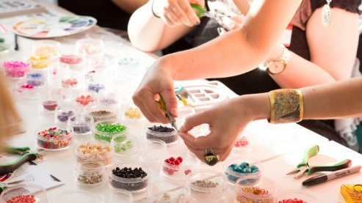](https://www.google.co.uk/url?sa=i&rct=j&q=&esrc=s&source=images&cd=&cad=rja&uact=8&ved=0ahUKEwinzdL11KTNAhXHK8AKHWiWBxYQjRwIBw&url=https://www.udemy.com/jewelry-making-wire-wrapped-jewelry-for-beginners/&bvm=bv.124272578,d.ZGg&psig=AFQjCNHT1vpPFKQo2QN6DydTb26PYOi8Vw&ust=1465895509108863)

[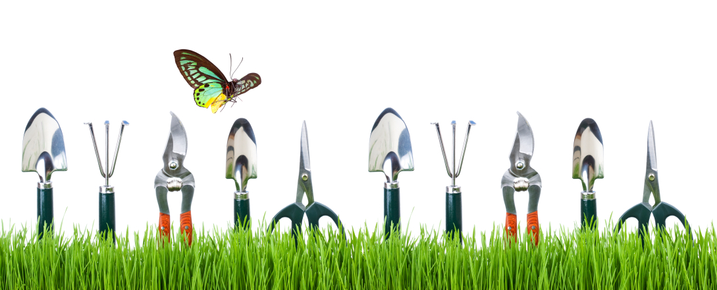](http://lerablog.org/home-and-family/an-overview-on-basic-gardening-tools/)

Free Creche spaces available on the day

For more information contact Rachael 07969184977 of ECLP Office 02920778128