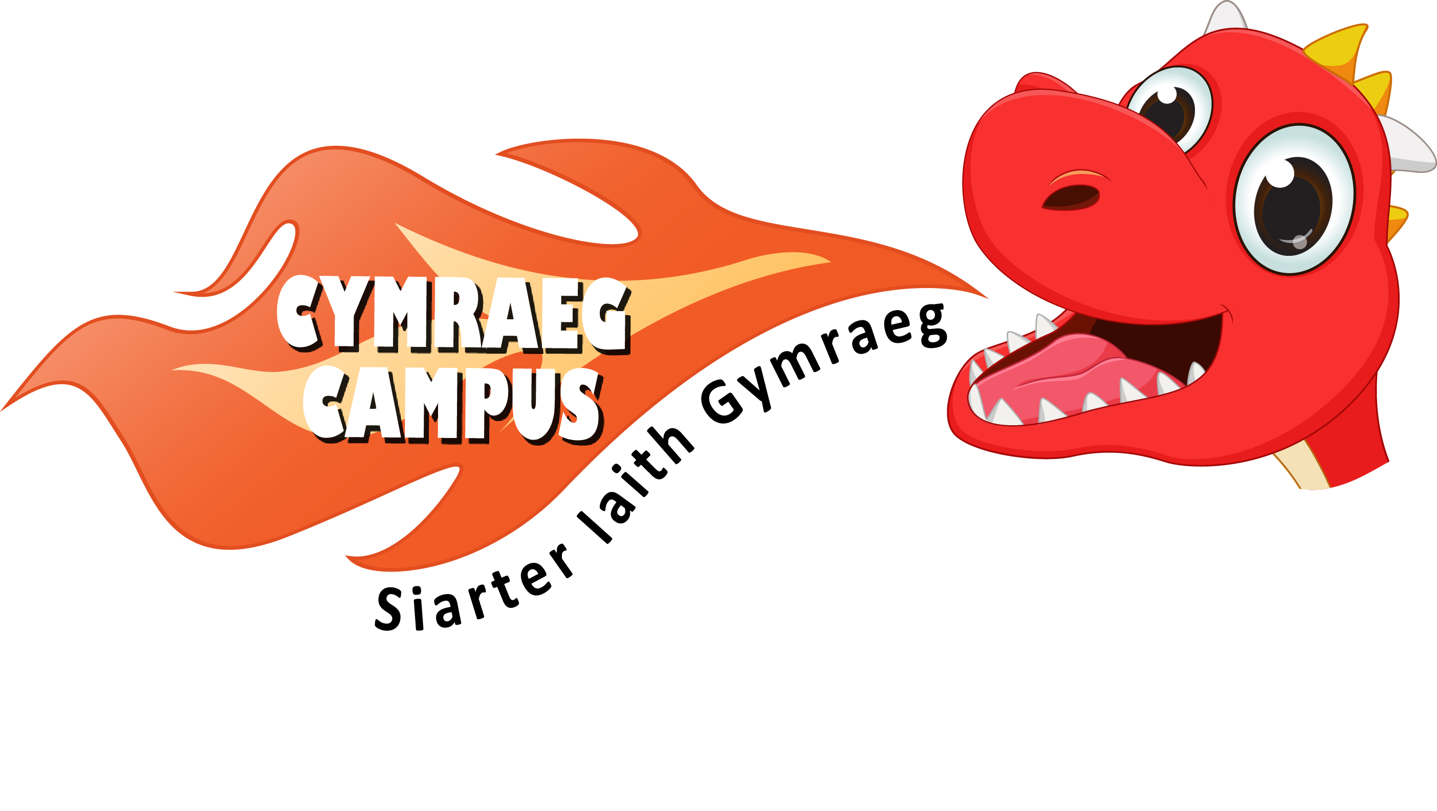
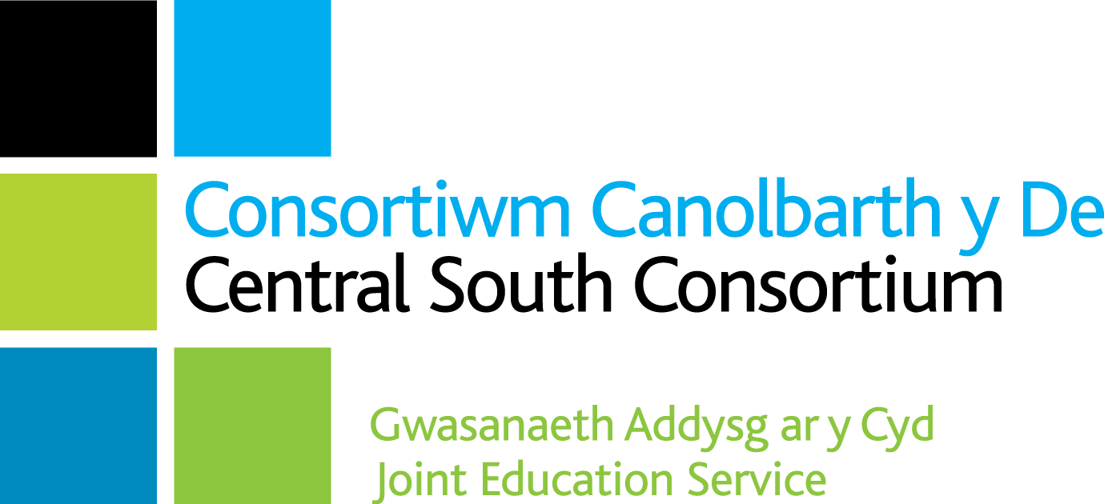
Adroddiad Siarter Iaith Cymraeg Campus
Siarter Iaith Cymraeg Campus Report

Ysgol / School: Meadowlane Primary
Gwobr / Award: Efydd

Targed /Target | Meysydd llwyddiannus /Areas of success | Taro’r targed/Target met?
Un - Sefydlu ethos Gymreig weledol  Visual Welsh ethos | A strong Welsh ethos throughout.  All classes have Welsh displays and reading areas.  All general signage is bilingual. | Yes
Dau - Manteision dysgu’r Gymraeg  Advantages of Welsh | Criw Cymraeg were clear about the advantages of learning Welsh. They encourage others through reward systems and Welsh assemblies.  Many enrichment activities have been enjoyed and the Criw Cymraeg help to plan these. They are currently looking forward to their Eisteddfod after half term. | Yes
Tri - Y defnydd o’r Gymraeg yn achlysurol o fewn yr ystafell ddosbarth Incidental Welsh in the classroom | Adults and pupils use incidental Welsh consistently.  Daily Helpwr Heddiw sessions are implemented in all classes.  Criw Cymraeg have an active role in promoting and monitoring the use of incidental Welsh. | Yes
Pedwar - Y defnydd o’r Gymraeg yn achlysurol y tu allan i’r ystafell ddosbarth Incidental Welsh outside the classroom | Welsh is consistently used by both adults and pupils to greet each other and ask questions around the school.  Criw Cymraeg have effective interactive displays in communal areas. | Yes
Pump - Cymraeg yn y Gwasanaethau  Welsh Assemblies | Criw Cymraeg introduce Welsh phrases in assemblies which are then displayed in school.  The Criw Cymraeg are increasingly taking ownership of the Welsh element of the assemblies through handing out rewards. | Yes
Chwech - Apiau a gwefannau i fireinio’r dysgu a’r mwynhad  Welsh Apps and Websites | Pupils use a range of Welsh websites and apps. iPads are utilised for Welsh tasks and accessing apps such as Campau Cosmig.  Pupils use software such as PowerPoint to complete Welsh tasks effectively. | Yes
Saith - Gweithgareddau cyfoethogi  Enrichment activities | An annual school Eisteddfod is held.  Criw Cymraeg help organise celebrations for Dydd Miwsig Cymru, Gŵyl Dewi, Santes Dwynwen etc. and hold a range of competitions throughout the school year. | Yes
Wyth - Datblygu darllen  Developing Reading | All classes have an appropriate range of reading resources.  Welsh books are clearly available in the school. Effective use of signage to promote Welsh reading. | Yes
Naw - Cymraeg ar draws y Cwricwlwm  Welsh across the curriculum | Evidence of Welsh across the curriculum is seen around the school and in books.  Purposeful Welsh phrases displayed where appropriate.  Welsh marking comments are used by staff. | Yes
Deg - Agwedd Gadarnhaol  Positive attitude to Welsh | Pupils and staff alike demonstrate a highly positive attitude to Welsh.  Members of the Criw Cymraeg obviously enjoy their role and are eager to continue and develop it further. | Yes

Sylwadau Cyffredinol / General Comments
- Siarter Iaith Cymraeg Campus is driven by strong leadership from the Welsh subject leader. The process is also supported highly effectively by the headteacher and all staff. The whole school approach at Meadowlane is evidently a strength.
- A highly enthusiastic Criw Cymraeg is instrumental in implementing, developing, and monitoring Siarter Iaith Cymraeg Campus. This ensures a strong pupil voice throughout the process.
- Extensive evidence has been collected for all ten targets digitally and there is very strong and attractive evidence clearly displayed and celebrated around the school.
- The school’s progress on the Siarter Iaith Cymraeg Campus journey is clearly shown on a display in a main hall.
- Whilst celebrating and taking pride in the school’s progress, the subject leader is eager to embed the good practice and continue to develop the Welsh ethos they have worked so hard to achieve. They hope to achieve the silver award.
Llongyfarchiadau i bawb yn Ysgol Meadowlane, rydych chi’n llwyr haeddu gwobr efydd Siarter Iaith Cymraeg Campus.
Congratulations to everyone in Meadowlane Primary, you richly deserve the Siarter Iaith Cymraeg Campus bronze award.

Prif Meysydd i’w Datblygu / Main Areas for Development
- The Criw Cymraeg to continue to monitor, encourage and lead the way on Welsh development.
- Continue to link with a Welsh medium primary school to work collaboratively on projects.
- Promote Welsh through community projects.

Dilyswyd gan/Verified by: Emma Richards

Dyddiad/Date: 16/02/2023

