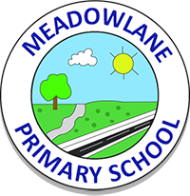
Meadowlane Primary School
Vision Statement
Following consultation with staff, governors, parents and children in June 2016, the school vision statement is:
‘Make yourself proud!’

Mission Statement
At Meadowlane Primary School we strive to create a warm, welcoming environment where our children feel safe, secure and happy. We have high expectations for every child and we celebrate effort and achievement. As an inclusive school we value diversity, respect each other as individuals, and embrace our differences.

School Aims
At Meadowlane Primary School we aim to:
- Give our children belief that they can achieve so they have the confidence to become ambitious, capable learners.
‘Believe you can achieve’

- Work in partnership with parents/ carers to ensure all our children are healthy and confident individuals.
‘Be healthy and confident’
- Provide an environment for all children built on respect for themselves and others so they are ready to be tolerant and responsible citizens of Wales and the wider world.
‘Celebrate our similarities and differences’

- Build our children’s aspirations by providing them with a wide range of enriched experiences and giving them the key skills of independence, perseverance, resilience and creativity so they are ready for their future lives.
‘Reach for the stars!’

