

COMPLAINTS PROCEDURE
Based on Welsh Government Guidance Document No. 011/2012
Introduction
Meadowlane Primary School is committed to dealing effectively with complaints. We aim to clarify any issues about which you are not sure. If possible, we will put right any mistakes we have made and we will apologise. We aim to learn from mistakes and use that experience to improve what we do.
Our definition of a complaint is ‘an expression of dissatisfaction in relation to the school or a member of its staff that requires a response from the school’.
This complaints procedure supports our commitment and is a way of ensuring that anyone with an interest in the school can raise a concern, with confidence that it will be heard and, if well-founded, addressed in an appropriate and timely fashion.
When to use this procedure
When you have a concern or make a complaint we will usually respond in the way that is explained below. Sometimes you might be concerned about matters that are not decided by the school, in which case we will tell you who to complain to. At other times, you may be concerned about matters that are handled by other procedures, in which case we will explain to you how your concern will be dealt with.
Have you asked us yet?
If you are approaching us for the first time, you should give us a chance to respond. If you are not happy with our response then you may make your complaint using the procedure described below.
Most concerns can be settled quickly just by speaking to the relevant person in school, without the need to use a formal procedure.
What we expect from you
We believe that all complainants have a right to be heard, understood and respected. School staff and governors have the same right. We expect you to be polite and courteous.
We will not tolerate aggressive, abusive or unreasonable behaviour. We will also not tolerate unreasonable demands or unreasonable persistence or vexatious complaining.

Our approach to answering your concern or complaint
- We will consider all your concerns and complaints in an open and fair way.
- At all times the school will respect the rights and feelings of those involved and make every effort to protect confidential information.
- Timescales for dealing with your concerns or complaints may need to be extended following discussion with you.
- We may ask for advice from the local authority.
- Some types of concern or complaint may raise issues that have to be dealt with in another way (other than this complaints policy), in which case we will explain why this is so, and will tell you what steps will be taken.
- The governing body will keep the records of documents used to investigate your concern or complaint for seven years after it has been dealt with. Records will be kept in school and reviewed by the governing body after seven years to decide if they need to be kept for longer.
- Complaints that are made anonymously will be recorded, but investigation will be at the discretion of the school, depending on the nature of the complaint.
- Where complaints are considered to have been made only to cause harm or offence to individuals or the school, the governing body will ensure that records are kept of the investigations that are made and what actions are being taken, including the reason for ‘no action’.
Answering your concern or complaint
Appendix A shows what may happen when you make a complaint or raise a concern. There are up to three stages: A, B and C. Most complaints can be resolved at stages A or B.
You can bring a relative or companion to support you at any time during the process, but you will be expected to speak for yourself.
When the complainant is a pupil, we recognise that it is reasonable for the companion to speak on their behalf and/or advise the pupil.
As far as possible, your concern or complaint will be dealt with on a confidential basis. However, there could be occasions when the person dealing with your concern or complaint will need to consider whether anyone else within the school needs to know about your concern or complaint, so as to address it appropriately.
Stage A
If you have a concern, you can often resolve it quickly by talking to a teacher or a member of the Senior Leadership Team. You should raise your concern as soon as you can; normally we would expect you to raise your issue within ten school days of any incident. The longer it is left, the harder it might be for those involved to deal with it effectively.
If you are a pupil, you can raise concerns with school council representatives, class teachers, or Mrs Ford, the headteacher. This will not prevent a later complaint if you feel that the issue(s) you have raised have not been dealt with properly.
We will normally let you know what we have done or are doing about your concern within ten school days, but, if this is not possible, we will talk to you and agree a revised timescale.
The person overseeing your concern or complaint will keep you informed of the progress being made. This person will also keep a log of the concern for future reference in a school complaints file.
Stage B
In most cases, we would expect that your concern is resolved informally. If you feel that your initial concern has not been dealt with appropriately, you should put your complaint in writing to the headteacher. We would expect you to do this within five school days of receiving a response to your concern. You may use the form in Appendix B. If you are a pupil, we will explain the form to you, help you complete it and give you a copy of what has been written down.
If your complaint is about the headteacher, you should put your complaint in writing to the chair of governors, addressed to the school, to ask for your complaint to be investigated.
We can help you to put your complaint in writing if necessary.
If you are the person making the complaint, we will explain what will happen and the sort of help that is available to you.
We will invite you to discuss your complaint at a meeting. Timescales for dealing with your complaint will be agreed with you. We aim to have a meeting with you and to explain what will happen within ten school days of receiving your letter. We will complete the investigation and will let you know the outcome in writing within ten school days of completion.
Stage C
If you still feel that your complaint has not been dealt with fairly, you should write, through the school’s address, to the chair of governors, setting out your reasons for asking the governing body’s complaints committee to consider your complaint.
We will let you know how the complaint will be dealt with and will send a letter to confirm this. The complaints committee of the governing body will normally have a meeting with you within 15 school days of receiving your letter.
The letter you receive will tell you when all the evidence and documentation to be considered by the complaints committee must be received. Everyone involved will see the evidence and documentation before the meeting, while ensuring that people’s right to privacy are protected.
The letter you receive will also record what has been agreed about when and where the meeting will take place and what will happen.
The complaints committee will not reschedule a meeting more than once. If you ask to reschedule a meeting more than once, the committee may think it reasonable to make a decision on the complaint in your absence to avoid unnecessary delays.
We will write to you within ten school days of the meeting, explaining the outcome.
We will keep records of all conversations and discussions for the purpose of future reference and review by the full governing body. These records will be kept for a minimum of seven years.
The governing body’s complaints committee is the final arbiter of complaints. Should there be evidence that a complaint has not been considered properly at Stage C and therefore that standards of governance are not good enough, then the local authority may consider using its powers of intervention. This power provides sufficient safeguard against bad practice in schools.
Special circumstances
Where a complaint is about any of the following, the complaints procedure will be applied differently:
A governor or group of governors: The concern or complaint will be referred to the chair of governors for investigation. The chair may alternatively delegate the matter to another governor for investigation. Stage B onwards of the complaints procedure will apply.
The chair of governors or headteacher and chair of governors: The vice-chair of governors will be informed and will investigate it or may delegate it to another governor. Stage B onwards of the complaints procedure will apply.
Both the chair of governors and the vice chair of governors: The complaint will be referred to the clerk of the governing body who will inform the chair of the complaints committee. Stage C of the complaints procedure will then apply.
The whole governing body: The complaint will be referred to the clerk to the governing body who will inform the headteacher, chair of governors and local authority. The authorities will usually agree arrangements with the governing body for independent investigation of the complaint.
The headteacher: The concern or complaint will be referred to the chair of governors who will undertake the investigation or may delegate it to another governor. Stage B onwards of the complaints procedure will apply.
Our commitment to you
In all cases, the school and governing body will ensure that complaints are dealt with in an unbiased, open and fair way.
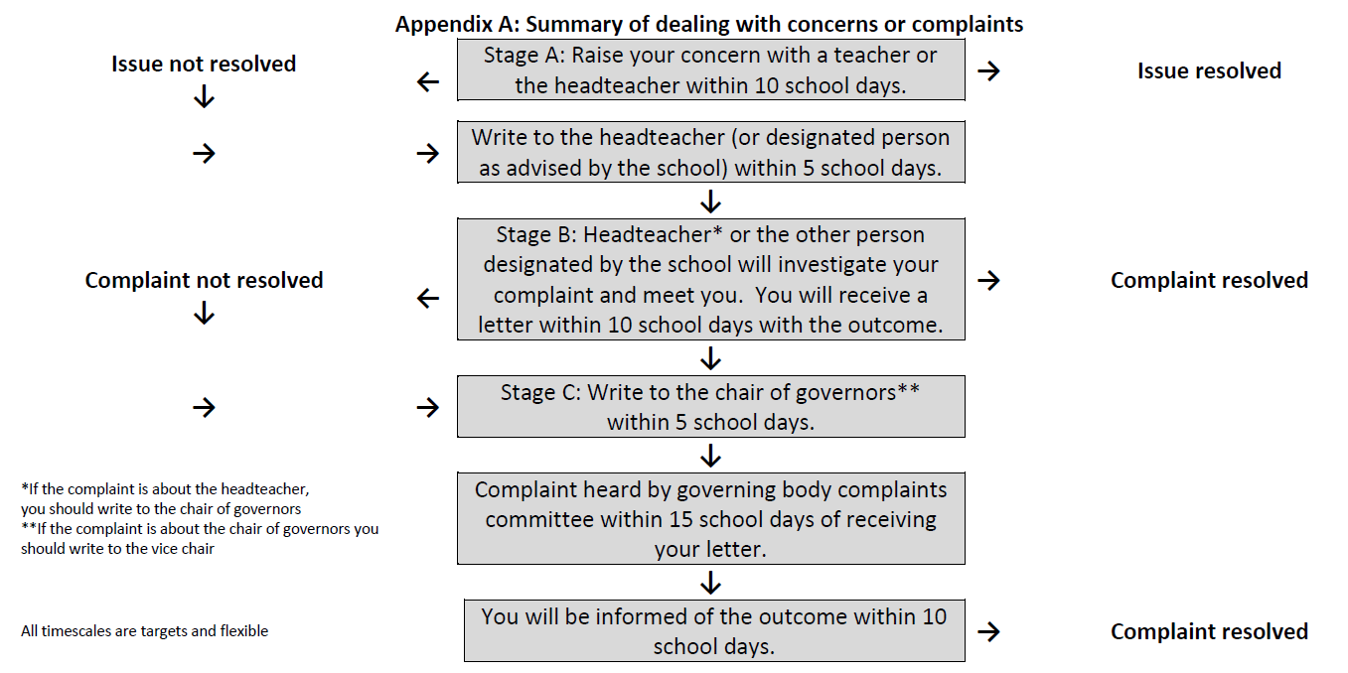
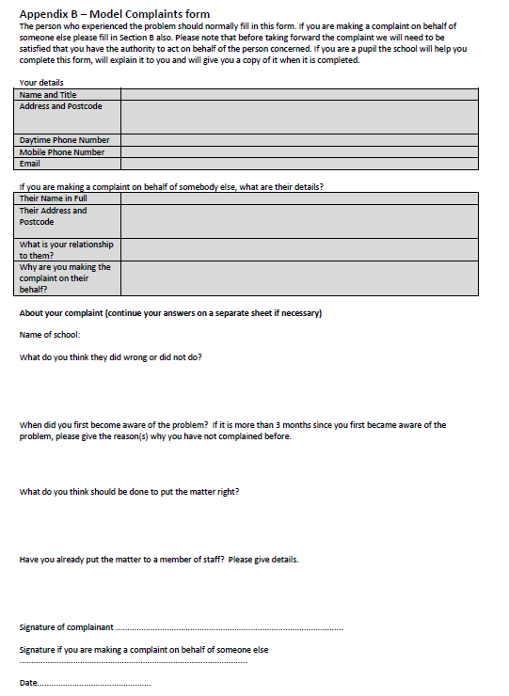
Review of Document

Date last reviewed | Signed
3/4/19 | C Ford

