Counter-Fraud & Corruption Strategy
Meadowlane Primary School

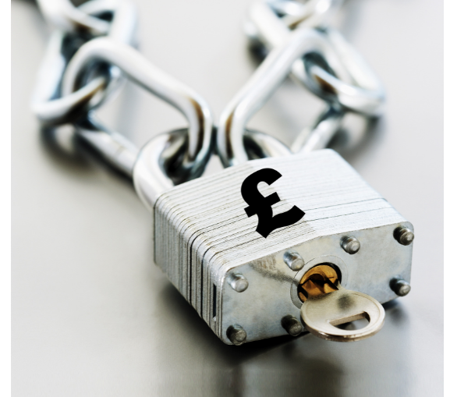


Contents |  | Page
1. | Objectives | 2
2. | Legal Background | 5
3. | Values | 7
4. | Assessing Fraud Risk | 8
5. | Roles & Responsibilities | 12
6. | Monitoring and Disclosures | 13
7. | Counter-Fraud Response Plan | 14
8. | Counter-Fraud Action Plan | 14
Appendices
a. | Counter-Fraud and Corruption Action Plan | 15
b. | Glossary – Fraud Types | 16
c. | A Desktop Guide to Reporting Fraud, Bribery and Corruption | 18

Foreword

Ensuring that we safeguard public funds is a top priority for Meadowlane Primary School, which is why we have adopted this Counter-Fraud and Corruption Strategy. This school policy is set out in conjunction with, and to supplement, Cardiff Council’s Counter-Fraud and Corruption Strategy.

With criminals increasingly seeking to exploit any weakness, we need to be vigilant to fraud risks. This strategy will help ensure that we take all appropriate measures to safeguard the school’s resources, which is more important than ever at a time of declining budgets.

Fraud affects our reputation and our ability to deliver educational services. All of us, therefore, have a responsibility to do all that we can to prevent fraud and proactively report any suspicions or concerns. This strategy sets out our responsibilities and the expectations of the school, and provides a framework for tackling fraud, bribery and corruption.

The active support of school staff will be essential in continuing to develop a culture in which fraud, bribery and corruption are understood to be unacceptable, and for which firm action will be taken.

Fraud and any acts of bribery and corruption will not be tolerated.

CHLOE FORD, HEADTEACHER
DAWN MITCHELL-WILLIAMS, CHAIR OF GOVERNORS

MEADOWLANE PRIMARY SCHOOL

- Objectives

This Strategy is designed to develop and maintain a culture in which fraud, bribery and corruption are understood as unacceptable, for which firm action will be taken to prevent and detect fraud loss, bring fraudsters to account quickly and efficiently, and to recover any losses.

Our Principles

The strategy will support us all to better understand fraud risk, and to prevent and detect fraud more effectively. The strategic response to fighting fraud with the school includes the following principles through which we:

- ‘Acknowledge’ and understand fraud risks, and take steps to tackle fraud through a robust anti-fraud response.

- ‘Prevent’ and detect more fraud, by making good use of technology, maintaining and enhancing fraud controls and processes and delivering an anti-fraud culture.

- ‘Pursue’ the punishment of fraudsters through the use of civil sanctions, recovery of losses and support to the law enforcement response.

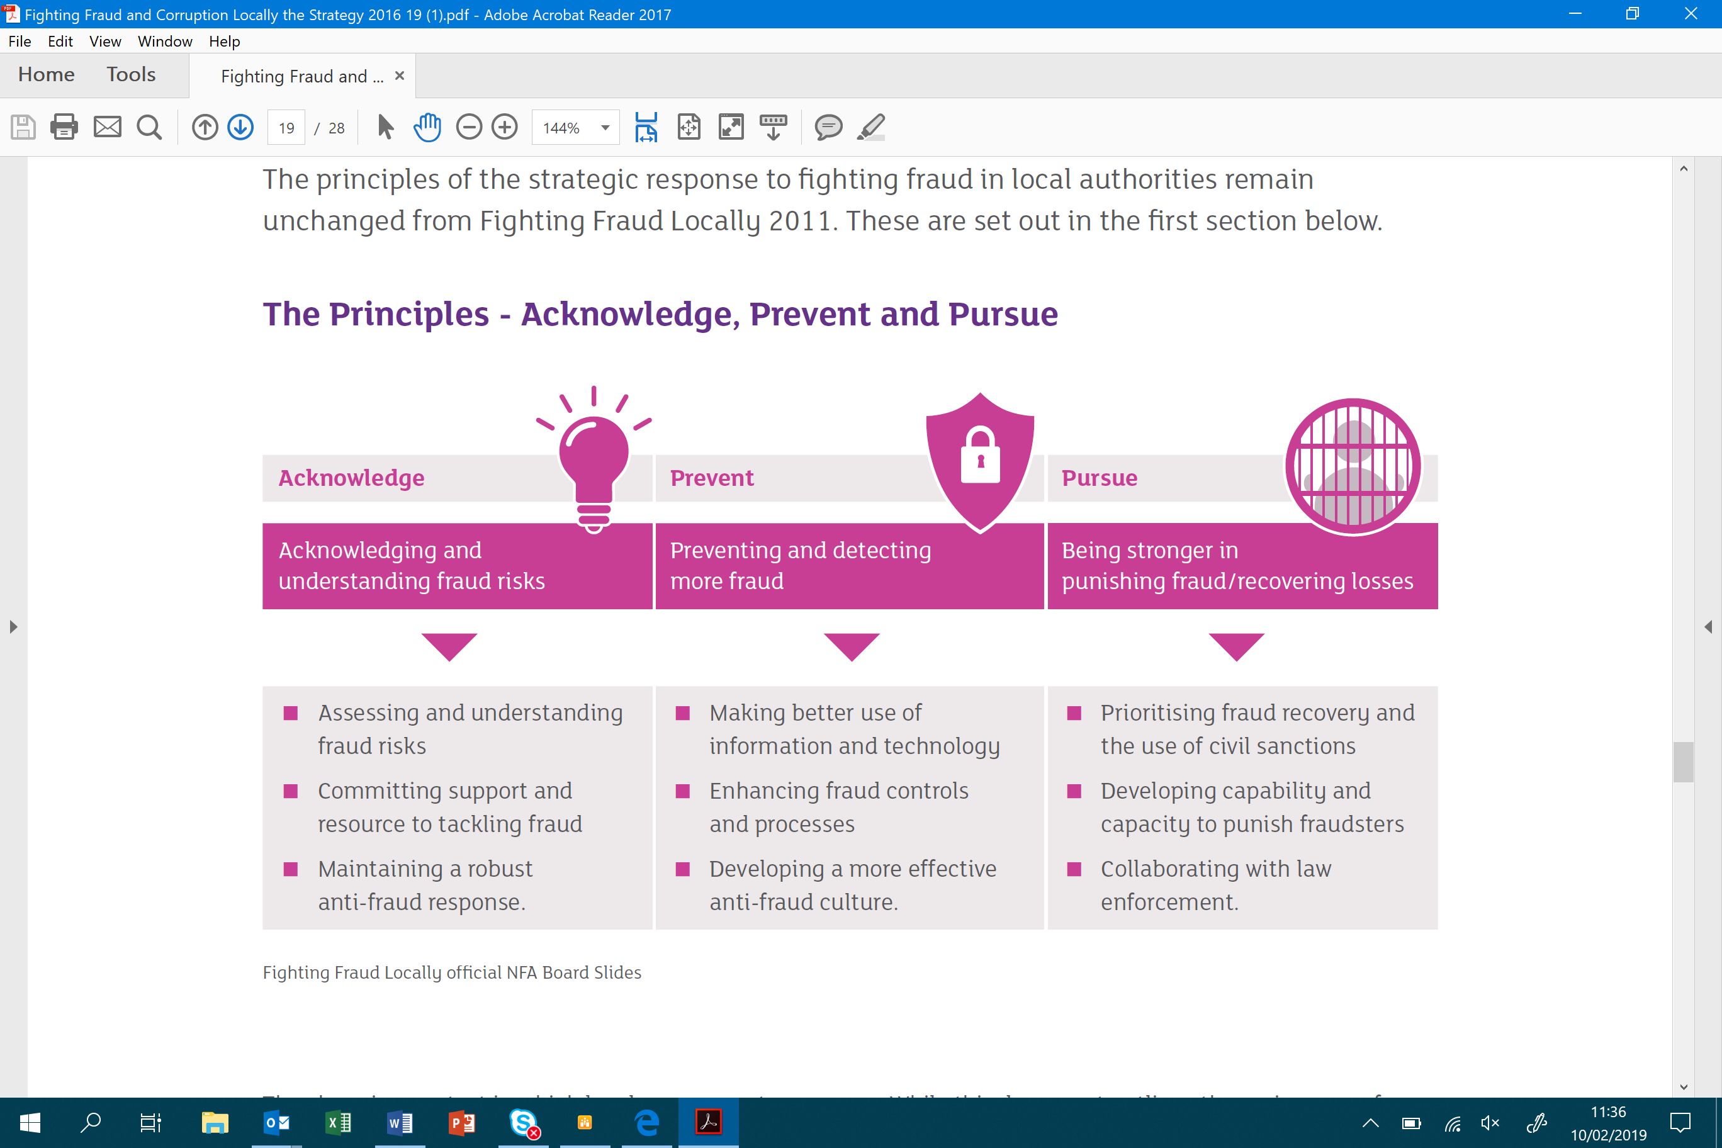

Fighting Fraud and Corruption Locally, Local Government Counter Fraud and Corruption Strategy, CIPFA 2016-2019

Our Targets

The Strategy is designed to support a fraud reporting culture, strong fraud awareness, assurance, and ownership within the school.

1. Reporting Culture - Everyone working for / representing the school (governors, employees, agency workers, temporary staff etc.) needs a good awareness of fraud risk and accountability for reporting, through training, communication activities and policy reviews. Members of the public and wider school community must know how and when to raise concerns.

2. Strong Assurance - The school’s internal control systems need to provide indications of any unusual patterns of activity or events that may point to potential fraudulent activity. Fraud risks must be understood, monitored and managed, to deliver strong school-wide assurance on fraud risk management.

3. Ownership - Everyone working for the school needs to understand their personal responsibility for supporting counter-fraud risk management. This should be considered in Personal Review objective setting.

Why is this important?

‘Fraud costs the public sector at least £20.6bn annually, and of this total, £2.1bn is specifically in local government.’

(Annual Fraud Indicator 2013, which provided the last set of government sanctioned estimates (England, Scotland, Wales and NI)).

Our Approach

The school’s approach for meeting the objectives of the strategy involves four core elements:

Risk Awareness - Completing relevant fraud awareness training and taking active steps to understand the nature and level of fraud risks. Effectively designing, operating and reviewing internal controls.

Culture - Supporting individuals in their responsibilities to prevent and detect fraud, through training and guidance to reinforce expectations. Communicating the school’s attitude to fraud by raising awareness of the counter-fraud policy framework, which supports the application of clear ethical standards.

Reporting - Providing, effectively communicating, and promoting, robust processes for reporting suspicions of fraud.

Fraud response - Responding to fraud effectively through a comprehensive fraud response plan, developing capability and capacity to investigate fraudsters, and delivering a collaborative and supportive response.

How we will deliver the strategy

Awareness, support and training for staff to understand and apply a strong counter-fraud culture. The Counter-Fraud Action Plan is included in Appendix A.

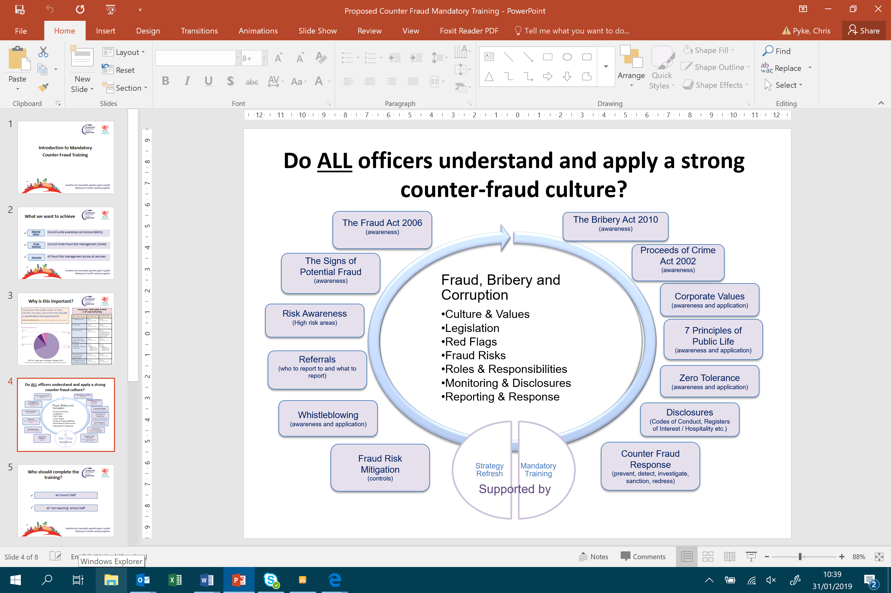

2. Legal Background

There are a number of pieces of legislation in place that we need to be aware of and ensure we adhere to, which are summarised below:

Fraud

The Fraud Act 2006 focusses on dishonest behaviour and the intent to make a gain either for yourself or another; to cause a loss to another; or, expose another to a risk of a loss. A person does not have to benefit from the fraud to be guilty of the offence. As soon as they have made a dishonest / false representation, they have committed fraud.

The offence of fraud can be committed in three ways, which are summarised below:
.
- Fraud by false representation – lying, or misleading someone in order to make a gain or cause a loss. E.g. falsifying information in a job application form

- Fraud by failing to disclose information – not stating something you have a legal duty to.
E.g. failing to declare a conviction, disqualification or commercial interest when such information may have an impact on your role, duties or obligation to declare.

- Fraud by abuse of a position – abusing a position where there is an expectation to safeguard the financial interests of another person or organisation.
E.g. abusing access to monies, or using commercially confidential information to make a personal gain, or cause a loss.

Fraud. Offences under the Fraud Act 2006 occur where the act or omission is committed dishonestly and with intent to cause gain or loss. The gain or loss does not have to succeed.

Successful prosecutions under the Fraud Act 2006 may result in an unlimited fine and/or a potential custodial sentence of up to 10 years.

Bribery and Corruption

Bribery and Corruption is covered by specific pieces of legislation:

The Bribery Act 2010 has made it a criminal offence to:
.
- Offer, promise or give a financial or other advantage to another person, and/or
- Request, agree to receive, or accept a financial or other advantage.

The Act contains further offences for commercial bribery. An offence relating to bribery of a foreign public official in order to obtain or retain business or an advantage in the conduct of business, and a form of corporate liability for failing to prevent bribery on behalf of a commercial organisation.

Bribery is generally defined as: an inducement or reward offered, promised or provided to someone to perform their functions or activities improperly in order to gain a personal, commercial, regulatory and/or contractual advantage.

A conviction under the Bribery Act 2010 may ultimately result in an unlimited fine and/or a custodial sentence of up to 10 years imprisonment.

Corruption is generally considered as an “umbrella” term covering such various activities as bribery, corrupt preferential treatment, kickbacks, cronyism, theft or embezzlement. Under the 2010 Act, however, bribery is now a series of specific offences.

A bribe does not have to be in cash; it may be the awarding of a contract, the provision of gifts, hospitality, sponsorship, the promise of work or some other benefit. The persons making and receiving the bribe may be acting on behalf of others – under the Bribery Act 2010, all parties involved may be prosecuted for a bribery offence.

Proceeds of Crime Act 2002 – The Act can be used for recovering criminal assets. Criminal confiscation is the most commonly used power, and this occurs after a conviction has taken place. The Act was introduced to deny criminals the use of their assets, to recover the proceeds of crime and to ‘disrupt and deter’ criminality.

Misconduct in Public Office: A common law offence for which the elements are:

a) A public officer acting as such.
b) Wilfully neglects to perform his duty and/or wilfully misconducts himself.
c) To such a degree as to amount to an abuse of the public's trust in the office holder.
d) Without reasonable excuse or justification.

This offence carries a maximum sentence of life imprisonment, and should be reserved for cases of serious misconduct or deliberate failure to perform a duty, likely to injure the public interest. Dishonesty or corrupt behaviour are not essential elements of the offence.

Other relevant legislation

The Criminal Finance Act 2017: Whilst this in the main relates to a UK tax evasion facilitation offence, Government guidance suggests prevention measures should be in place similar to the prevention measures under s7 of the Bribery Act 2010. The school needs to have policies and procedures in place to prevent tax evasion from occurring.

The Serious Crime Act 2015: The Serious Crime Act gives effect to a number of legislative proposals in relation to serious and organised crime. In doing so, it builds on current law to ensure that the relevant bodies have the powers they need to effectively and relentlessly pursue, disrupt and bring to justice serious and organised criminals.

The Public Contracts Regulations 2015: Where a contracting authority has knowledge that a company or its representatives have been convicted of a corruption offence, they should be treated as ineligible (debarred) to participate in the tendering process. Companies cannot be permanently debarred, but instead will face a term of debarment, dependent on the case, that can be no longer than five years from the date of the conviction. Public authorities are also obliged to bring debarment to an end when the company can satisfactorily demonstrate ‘self-cleaning’.

3. Values

General Integrity and Ethical Values

Meadowlane Primary School has a strong commitment to integrity, ethical values and the law, through the school’s values, supporting policies and procedures:

- School Values - guide the school community and communicate expectations to our stakeholders on conduct and behaviour.

- Induction and Training Processes - are in place for all staff and governors to ensure awareness and understanding on a range of policies, procedures and regulations.

- A Whistleblowing Policy – encourages staff and contractors to speak out on misconduct or illegal behaviour within the School, which affects the public or other people (making a disclosure in the public interest).

- Zero Tolerance attitude to fraud, bribery and corruption – requires staff and governors to act honestly and with integrity at all times, and to promptly report concerns

Zero Tolerance to Fraud

The school requires staff, governors and those we engage with, to act honestly and with integrity at all times. Zero tolerance is given to those committing or attempting fraudulent or corrupt acts (including bribery) inside and/or outside of the school, through:

- Acting robustly and decisively when fraud, bribery and corruption are suspected and proven e.g. the termination of contracts, dismissal, prosecution etc;

- Taking action to recover any losses through fraud, bribery and corruption e.g. through agreement, court action, penalties, insurance etc;

- Having sound internal control systems, which allow for innovation, whilst limiting opportunities for fraud, bribery and corruption;

- Optimising the publicity opportunities associated with anti-fraud and corruption activity.

4. Assessing Fraud Risk

Meadowlane Primary School relies upon proactive and reactive work across the school in order to effectively prevent and detect fraud.

The first line of defence is the internal control environment, in which there needs to be a culture of accountability, a zero tolerance to fraud, supported by a robust application of controls, to prevent fraud and ensure a reporting culture for any concerns.

Awareness and training are essential to ensure a whole-school response to counter-fraud. The school’s approach to awareness and training is programmed in the Counter-Fraud Action Plan (see Appendix A).

The most recent data on the relative proportions of detected local authority fraud by volume is shown below. The associated fraud risk descriptions are included within the glossary in Appendix B.

The following pages explain the process that is followed to develop the fraud risk assessment, starting with national data and intelligence, and then integrating school intelligence. This strategy and the associated activities included in the Counter-Fraud Action Plan, are focussing greater attention to an organisation-wide fraud risk awareness, and the reporting of suspicions and concerns from all levels of the organisation.

National Trends & Intelligence

- Detected Fraud in UK Local Authorities (by Volume)

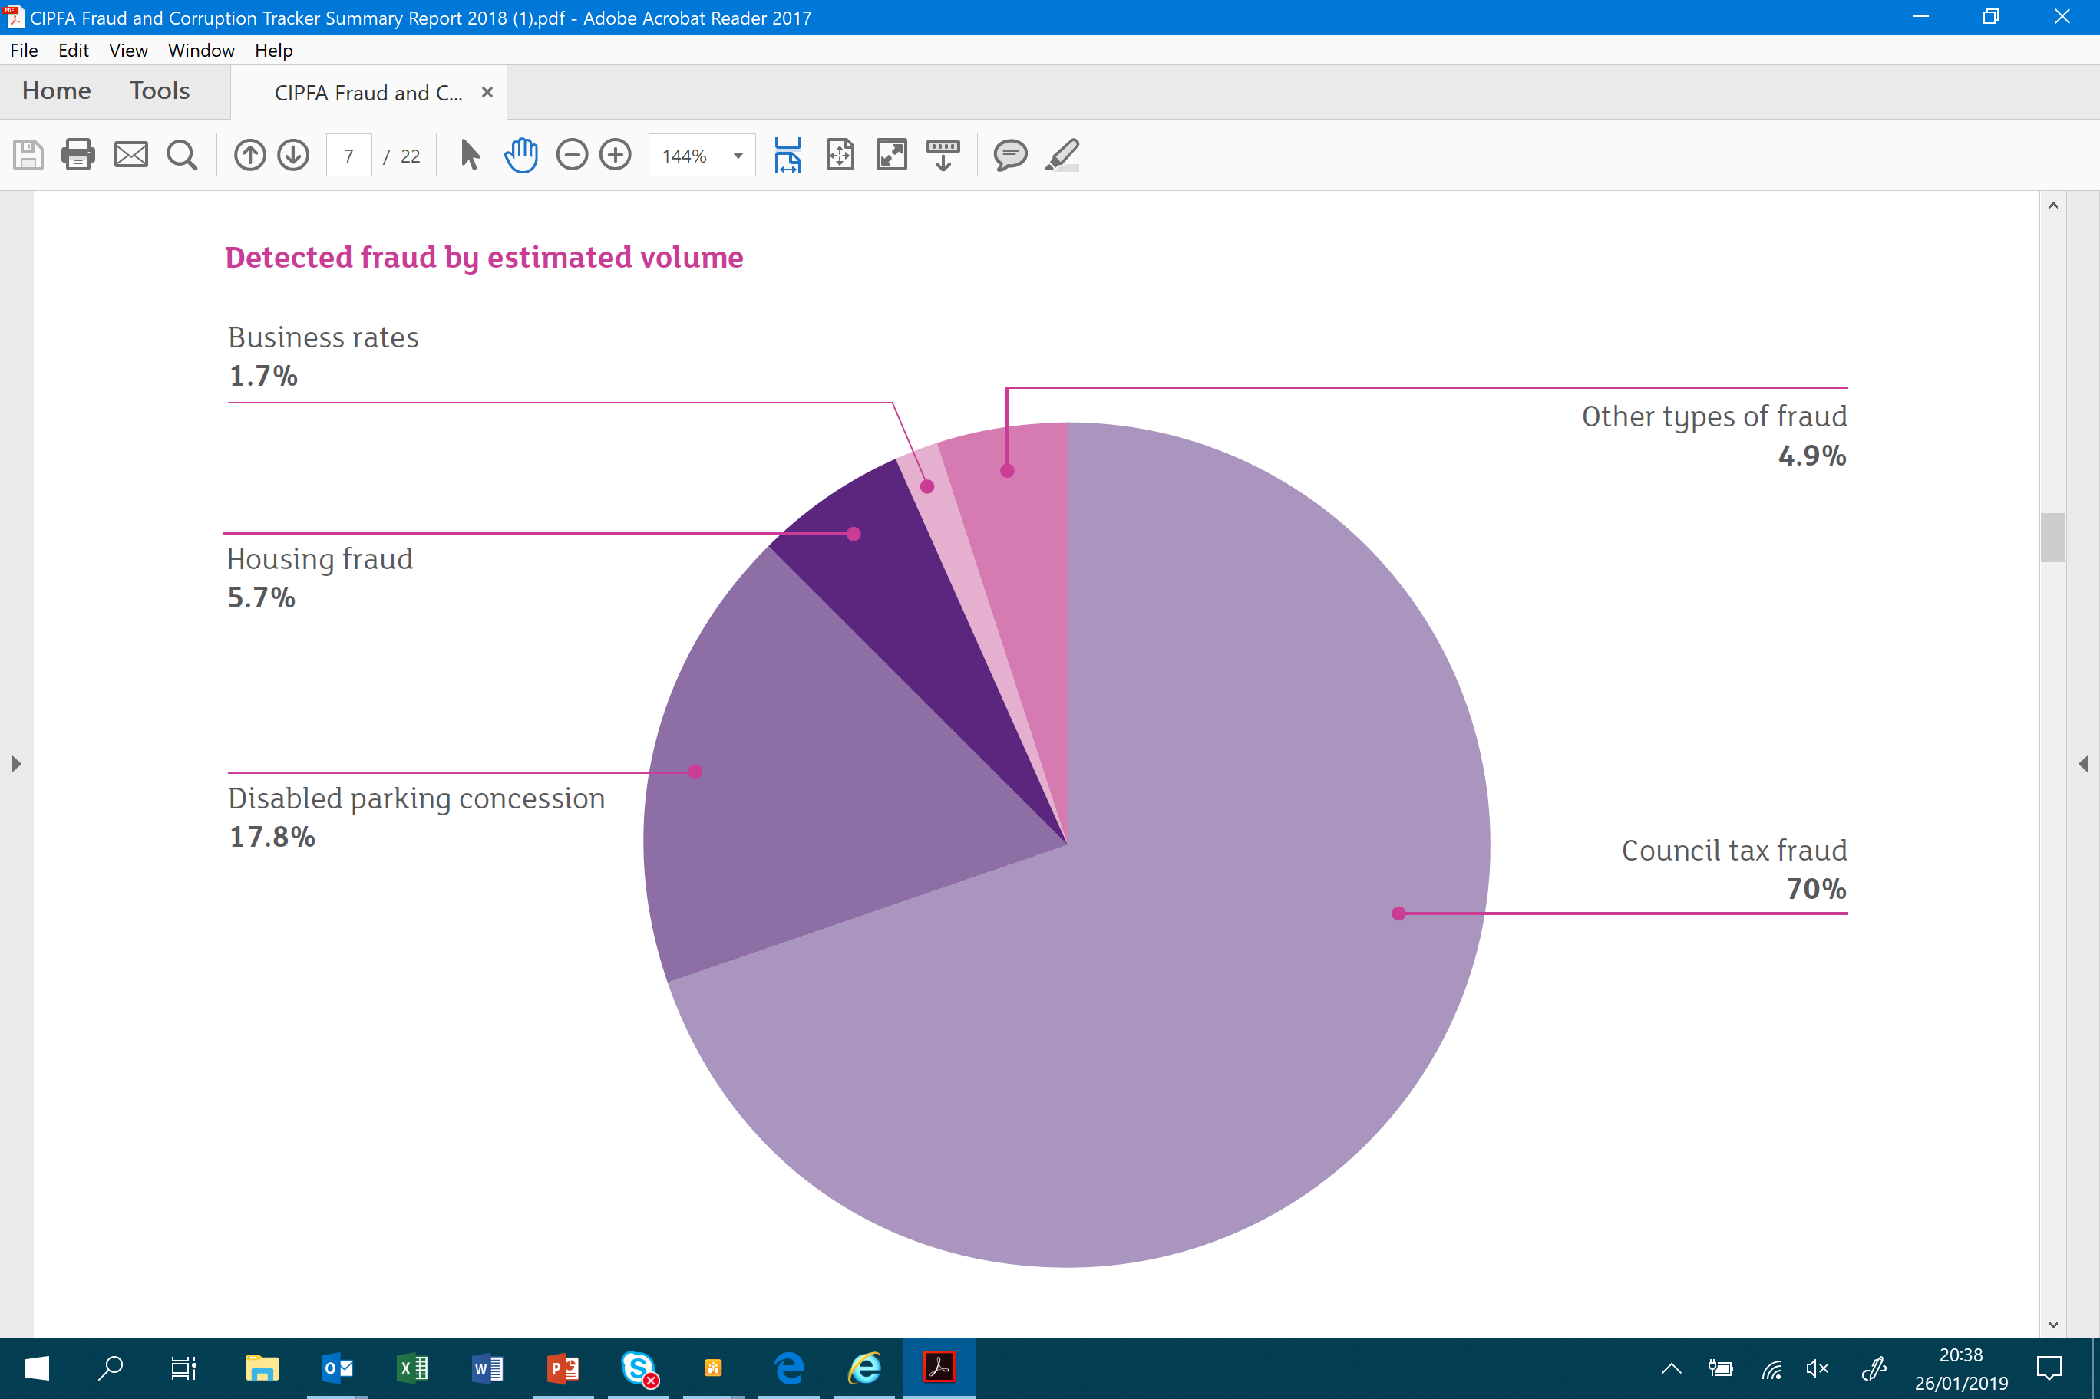

A number of the ‘other’ types of fraud (4.9% of detected volume) are of particular relevance within a school setting, and comprise the following, shown in order of frequency across UK local authorities, ordered from most frequent to least.

- Primary ‘other’ types of fraud in UK Local Authorities in 2017/18

Primary ‘Other’ Types of Fraud | Estimated value ‘overall’ | Estimated value ‘per fraud’
Adult Social Care fraud | £6.7m | £9.1k
Mandate fraud and manipulation of data | £6.6m | £25.6k
Procurement fraud | £5.2m | £36.4k
No recourse to public funds / welfare assistance fraud | £4.3m | £11.4k
Insurance fraud | £3.5m | £12.3k
Payroll, recruitment, expenses and pension fraud | £2.1m | Payroll - £6k  Recruitment - £9.5k  Expenses - £867  Pensions - £3.4k
Economic and voluntary sector support & debt fraud | £0.8m | £13.4k

CIPFA, Fraud and corruption tracker 2018

School Intelligence

Meadowlane Primary School uses a number of sources of intelligence to identify its fraud risk, which build upon the national intelligence data that we receive. The school uses the following primary means to identify its fraud risk assessment.

Management Risk Assessments
External Assurance Reports
Investigation Findings

Internal Audit Assurance
National Intelligence
Data Analysis

Whistleblowing
Review
Monitoring

Building on national intelligence sources, three principal areas used to further refine the understanding of fraud risk, are as follows:

1. Internal Control Environment
(Senior Leadership and Governing Body Assurance)

The Headteacher and Governing Body are responsible for ensuring that systems and processes in place minimise fraud risk and are operating as they should, installing and monitoring strong physical and system controls to prevent fraud risks, and effective mechanisms to detect and respond to potential fraud. The Headteacher and Governing Body will monitor the controls in place to manage fraud risk, allegations of fraud, and other intelligence or red flags for fraud.

The Council’s Internal Audit team provides independent assurance on the operation of internal controls. The Internal Audit plan is responsive to fraud risk, with national data and intelligence used to inform an inherent risk assessment, which is further refined by additional sources of assurance. Audit test programmes assess the risk of fraud and the effectiveness of key controls to mitigate fraud. The work of audit provides a secondary assessment of the fraud risk.

2. Whistleblowing

The school’s Whistleblowing Policy is a means through which those working for, or with us, can make a disclosure in the public interest, and this may relate to an allegation of fraud or financial impropriety. Staff are often the first to realise that there may be something significantly wrong within the school. Meadowlane Primary School is committed to the highest possible standards of openness, probity and accountability. In line with that commitment, we expect staff, and others that we deal with, who have serious concerns about any aspect of the school’s work to come forward and voice those concerns.

The Right Conditions for Fraud

A concept known as the fraud triangle refers to a ‘perfect storm’ where the following three elements, leading to fraud, coincide. At the same time as upholding our own values, we need to be alert to the presence of these conditions in others, and to work on reducing the elements which are in our control as colleagues.

The Fraud Triangle

2. Opportunity
1. Pressure

3. Rationalisation

Concept developed in 1950s by Criminologist Dr Donald Cressey.

- Pressure or motivation to commit fraud can come from a range of sources e.g. a detrimental change to an individual’s personal financial situation.

- Opportunity to commit fraud generally results from poor controls in place within directorates i.e. failing to put in place measures to prevent attempted fraudulent acts. It is the responsibility of the Headteacher, in the first instance, to install and monitor effective controls, with all staff expected to report any concerns they have directly to the Headteacher or the Governing Body.

- Rationalisation is a person’s justification to go about committing a crime. If the right culture and values are upheld, then regardless of the above two elements, people will not commit fraud.

Red Flags for Fraud

There are a number of behavioural characteristics, which may alert us to a greater risk of fraud. These are known as ‘Red Flags’, and we are all responsible for keeping alert to the presence of these behavioural characteristics in those that we work with, and reporting concerns to the Headteacher or Governing Body and, where appropriate, to the Council’s Audit Manager.

In its 2016 Report to the Nations on Occupational Fraud and Abuse, the Association of Certified Fraud Examiners identified behavioural red flags that many fraud perpetrators exhibit as follows:
- Living beyond one’s means.
- Financial difficulties.
- An unusually close association with a vendor or customer.
- Control issues or an unwillingness to share duties.
- Wheeler-dealer attitude involving shrewd or unscrupulous behaviour.
- Irritability, suspiciousness, and defensiveness.
- Addiction problems.
- Refusal to take holidays
- Complaining about their lack of authority.
- Excessive gambling.
- Increased smoking.
- Making up excuses for missing documents, income, and finding scapegoats.

System / Data ‘Red Flags’

Inventory shrinkage | Missing documents | Multiple payments
Spikes in invoice volume | Frequent complaints | Excessive number of adjusting entries

5. Roles and Responsibilities

Meadowlane Primary School recognises the threat of fraud and corruption, and the harm they can cause to our organisation, our aims and objectives, and our community.

It is important that we all recognise our personal accountability for managing the risk of fraud, bribery and corruption. To be able to ‘acknowledge’, ‘prevent’ and ‘pursue’ potential instances of fraud we need to work together and each understand the active role we must play. Our primary responsibilities for supporting a counter-fraud culture are included below.

Roles | Primary Responsibilities
All Staff | - Complete all mandatory training;  - Uphold strong standards of conduct and compliance;  - Maintain physical and system controls to prevent and detect fraud;  - Keep aware of fraud risks and report suspicions.
Governors | - Complete all mandatory training;  - Uphold strong standards of conduct and compliance;  - Support a reporting culture and take appropriate action;  - Reinforce a culture of accountability and ‘zero tolerance’ to fraud.
Headteacher and Designated Officers | - Complete all mandatory training;  - Uphold strong standards of conduct and compliance;  - Maintain physical and system controls to prevent and detect fraud;  - Regularly assess, monitor and manage fraud risks;  - Support a reporting culture and take appropriate action;  - Reinforce a culture of accountability and ‘zero tolerance’ to fraud.

Reporting Culture

Through your day-to-day work, you are in the best position to recognise specific risks within your areas of responsibility, or those working closely with you. Where you believe the opportunity for fraud, corruption or bribery exists, whether because of poor procedures or oversight, you should report in accordance with the following simple steps.

If you believe you have identified potential fraud:

- Report the matter to the Headteacher as soon as possible. The Headteacher should attempt to establish as many details as possible (through discussion with the notifying member of staff only).

OR

- If the concern relates to the Headteacher and/or Governing Body, report the matter direct to the Council’s Audit Manager (Chris Pyke).

- Following any notification of fraud, financial impropriety or irregularity, the Headteacher or Chair of Governors should, in the first instance, send an email to the Council’s Group Auditor Investigations, d.hexter@cardiff.gov.uk summarising the allegation(s), including as much detail as possible.

NB. Key Contact information is included in Appendix D, and the investigation process is included in the Council’s Fraud Bribery and Corruption Policy.

Further Reporting Mechanisms:

- Wales Audit Office Whistleblowers’ Hotline 029 20 320 522
- Public Services Ombudsman for Wales 0300 790 0203
- Public Concern at Work 020 3117 2520

6. Monitoring and Disclosures

The school requires a number of disclosures to be made, to reinforce its counter-fraud culture. The primary policies in which disclosures are required relate to:

- Codes of Conduct (Staff and Governors)

- Registers of Interest

- Register of Gifts and Hospitality

- Whistleblowing

In upholding strong standards of conduct and compliance, it is vital that we work in accordance with the full requirements of these policies and codes. All relevant interests, gifts, and hospitality, received in accordance with the respective policies, needs to be fully disclosed.

7. Counter-Fraud Response Plan

The school’s approach to counter-fraud includes a number of proactive and responsive elements.

Proactive
- Developing a counter-fraud culture to increase resilience to fraud;
- Preventing fraud through the implementation of appropriate and robust internal controls and security measures;

Responsive
- Implementing effective whistleblowing arrangements;
- Investigating fraud referrals;
- Applying sanctions, including internal disciplinary, regulatory and criminal;
- Seeking redress, including the recovery of assets and money where possible.

Counter Fraud Policy and Document Framework

Discipline, Conduct, Capability & Grievance Procedures

Authority List / Delegation Approvals

School Financial Regulations

Codes of Conduct
Registers of Interest
Whistleblowing Policy

Fraud, Bribery and Corruption Policy
ICT Security Policy
Gifts and Hospitality Policy and Register

Complaints Procedures
Charging and Remissions Policy
Admissions Policy

Each of the above documents supports the school to achieve one or more of its Counter-Fraud objectives as follows:

- ‘Acknowledge’ and understand fraud risks
- ‘Prevent’ and detect more fraud
- ‘Pursue’ and punish fraudsters

These core documents need to be robustly applied, and adhered to, by all of us.

Included in Appendix C is a desktop guide for wide publicity and use in the school.

8. Counter-Fraud Action Plan

The Headteacher and will produce a Counter-Fraud Action Plan on an annual basis to summarise the key Counter-Fraud work and initiatives scheduled for the academic year.

The Governing Body will oversee the delivery of Counter-Fraud activities.

Counter-Fraud and Corruption Action Plan
Appendix A
[This template is included for schools to edit and insert their policies and activities, including timescales for review – reference should be made to the counter-fraud policies and documents listed on the previous page

Ref. | Action Required | Timescale
Anti-fraud and Corruption Policies Updates (Primary Policies)
1. | Counter Fraud and Corruption Strategy to be reviewed and agreed by FP&P Committee 13/11/24 and adopted by Full Governors 11/12/24 | Review annually
2. | Staff Code of Conduct to be reviewed by FP&P Committee Autumn 2025 and adopted by Full Governors Autumn 2025 | Review every 3 years
3. | Register of Interests to be completed by staff who have responsibility for finances and procurement and all governors by December 2024 | Review annually
4. | Gifts and Hospitality Policy to be reviewed and agreed by FP&P Committee Autumn 2025 and adopted by Full Governors Autumn 2025 | Review every 3 years
5. | Whistleblowing Policy to be reviewed and agreed by FP&P Committee Autumn 2025 and adopted by Full Governors Autumn 2025 | Review every 3 years
Information Reviews
6. | Reminder of all above policies to all staff | By September 2024
Training and Awareness Raising
7.

Appendix B
Glossary – Fraud Types
CIPFA Fraud and Corruption Tracker 2018

School Related
1. Cautions
Cautions relate to a verbal warning given in circumstances where there is enough evidence to prosecute, but it is felt that it is not in the public interest to do so in that instance.
2. Debt fraud
Debt fraud includes fraudulently avoiding a payment of debt to an organisation, excluding council tax discount.
3. Disciplinary outcomes
Disciplinary outcomes relate to the number of instances where, as a result of an investigation by a fraud team, disciplinary action is undertaken, or where a subject resigns during the disciplinary process.
4. Economic and voluntary sector (grant fraud)
This type of fraud relates to the false application or payment of grants or financial support to any person and any type of agency or organisation.
5. Insurance fraud
This fraud includes any insurance claim that is proved to be false, made against the organisation or the organisation’s insurers.
6. Mandate fraud
Action Fraud states that: “mandate fraud is when someone gets you to change a direct debit, standing order or bank transfer mandate, by purporting to be an organisation you make regular payments to, for example a subscription or membership organisation or your business supplier”.
7. Manipulation of data fraud
The most common frauds within the manipulation of data relate to employees changing data in order to indicate better performance than actually occurred and staff removing data from the organisation. It also includes individuals using their position to change and manipulate data fraudulently or in assisting or providing access to a family member or friend.
8. No recourse to public funds fraud
No recourse to public funds prevents any person with that restriction from accessing certain public funds. A person who claims public funds despite such a condition is committing a criminal offence.
9. Organised crime
The Home Office defines organised crime as “including drug trafficking, human trafficking and organised illegal immigration, high value fraud and other financial crimes, counterfeiting, organised acquisitive crime and cyber crime”.
10. Procurement fraud
This includes any fraud associated with the false procurement of goods and services for an organisation by an internal or external person(s) or organisations in the ‘purchase to pay’ or post contract procedure, including contract monitoring.

11. Whistleblowing
Effective whistleblowing allows staff or the public to raise concerns about a crime, criminal offence, miscarriage of justice or dangers to health and safety in a structured and defined way. It can enable teams to uncover significant frauds that may otherwise have gone undiscovered. Organisations should therefore ensure that whistleblowing processes are reviewed regularly.

Wider Fraud Definitions
12. Adult social care fraud
Adult social care fraud can happen in a number of ways but the increase in personal budgets gives a greater opportunity for misuse.

Investigations cover cases where:
- direct payments were not being used to pay for the care of the vulnerable adult
- care workers were claiming money for time they had not worked or were spending the allocated budget inappropriately.
13. Blue Badge fraud
The Blue Badge is a Europe-wide scheme allowing holders of the permit to parking concessions which are locally administered and are issued to those with disabilities in order that they can park nearer to their destination.
Blue Badge fraud covers abuse of the scheme, including the use of someone else’s Blue Badge, or continuing to use or apply for a Blue Badge after a person’s death.
14. Business rates fraud
Business rates fraud is not a transparent landscape for the fraud investigator, with legislation making it difficult to separate between evasion and avoidance. Business rates fraud covers any fraud associated with the evasion of paying business rates including, but not limited to, falsely claiming relief and exemptions where not entitled.
15. Council tax fraud
Council tax is the tax levied on domestic properties and collected by district and unitary authorities in England and Wales and levying authorities in Scotland.
Council tax fraud is split into three sections:
- council tax single person discount (SPD) – where a person claims to live in a single-person household when more than one person lives there
- council tax reduction (CTR) support – where the council tax payer claims incorrectly against household income
other types of council tax fraud – e.g. claims for exemptions or discounts to which the council tax payer has no entitlement.
6. Housing fraud
Fraud within housing takes a number of forms, including sub-letting for profit, providing false information to gain a tenancy, wrongful tenancy assignment and succession, failing to use the property as the principle home, abandonment, or right to buy.
17. Right to buy
Right to buy is the scheme that allows tenants that have lived in their properties for a qualifying period the right to purchase the property at a discount.
18. Welfare assistance
Organisations have a limited amount of money available for welfare assistance claims so the criteria for applications are becoming increasingly stringent. Awards are discretionary and may come as either a crisis payment or some form of support payment.

A Desktop Guide to Reporting Fraud, Bribery and Corruption
Appendix D

FRAUD is the dishonest intent to obtain a financial gain from, or cause a financial loss to, a person or party through false representation, failing to disclose information or abuse of position.
CORRUPTION/BRIBERY is the offering, promise, giving, requesting, agreeing to receive, or accepting a payment or other advantage to induce or reward a person to improperly carry out their duties

DO NOT
- Confront the suspect or convey concerns to anyone other than those authorised
Never attempt to question a suspect yourself; this could alert a fraudster and place you at harm and jeopardise an investigation/put evidence at risk.
- Try to investigate the concern yourself
Never attempt to gather evidence yourself unless it is about to be destroyed; speak with the Council’s Counter-Fraud Specialist as soon as possible for advice and guidance.
- Be afraid of raising your concerns
The Public Interest Disclosure Act 1998 protects employees who have reasonable concerns. You will not suffer discrimination or victimisation by following the correct procedures.
- Do nothing!
DO
- Note your concerns
Record details such as your concerns, names, descriptions, dates, times, details of conversations and possible witnesses. Time, date and sign your notes.
- Retain or secure evidence
Retain any evidence that may be destroyed, but do not alter or write on it an in any way.
- Report your suspicion promptly
Confidentiality will be respected – delays may lead to further financial loss.
- Be discreet
Don’t discuss your concerns with anyone who doesn’t need to know.

If you suspect that fraud against the school has taken place, you must report it immediately in line with the school’s Fraud, Bribery, and Corruption Policy:
- To the Headteacher or Chair of Governors in the first instance and
- To the Audit Manager (Chris Pyke)
- Via email to the Group Auditor Investigations (d.hexter@cardiff.gov.uk)

Fraud, Bribery & Corruption – for further advice, you may contact:
Audit Manager
Internal Audit, County Hall, Cardiff. CF10 4UW
Telephone: 2087 2284
All calls will be treated in confidence and investigated by professionally trained personnel

Protecting your school from Fraud, Bribery and Corruption
The Council’s nominated Counter-Fraud Specialist is David Hexter, who can be contacted by telephoning 029 2087 2284, or emailing d.hexter@cardiff.gov.uk
If you would like further information about Cardiff Council Fraud Activities, please visit our SharePoint site.

