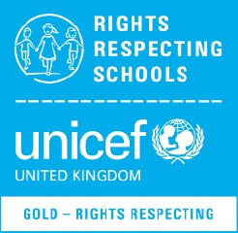
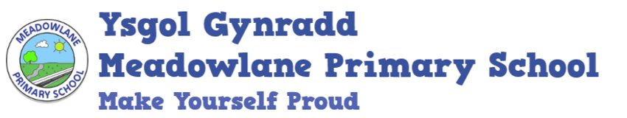

Home School Agreement

‘As a Rights Respecting School, we are committed to promoting, realising and respecting the United Nations Convention on the Rights of the Child (UNCRC). This agreement links directly to Article 28: The right to an education and Article 29: The right to develop goals of education.

This agreement supports the commitment of both home and school in working together to ensure that all pupils are given the best education to support their well-being and learning.

The school will:

- Provide a nurturing, happy and safe environment.
- Support pupils to understand their rights.
- Develop positive relationships with pupils to support good behaviour.
- Use restorative approaches to address any negative behaviours or bullying.
- Inform parents of any concerns that may affect their child’s work or behaviour.
- Teach pupils how to safe online.
- Give every pupil the opportunity to make good progress in their well-being and learning.
- Provide opportunities for parents to discuss their child/children's progress throughout the academic year.
- Provide an annual written report to parents at the end of each school year.
- Keep parents informed regarding learning experiences through Dojo and the weekly newsletter.

Parents/ carers will:

- Ensure that your child has good levels of attendance to enable them to access their learning and make good progress.
- Ensure that your child arrives on time every day so they are able to access the full curriculum.
- Ensure that your child wears the correct school uniform.
- Ensure that suitable arrangements are made for your child to be collected, on time, at the end of the school day.
- Ensure the school is able to contact emergency numbers during the school day and numbers are kept up to date.
- Monitor your child’s use of technology to ensure they stay safe online.
- Encourage your child to be polite and follow the school rules.
- Ensure that your child comes to school alert, refreshed and ready to learn.
- Support the school by not allowing your child to use swear words or insulting language.
- Let the teacher know of any concerns that may affect your child’s work or behaviour.
- Ensure that the school is kept fully informed if your child is absent from school.

Pupils will:

- Tell an adult if something is making them unhappy.
- Follow the school rules.
- Be polite and caring to others.
- Always try their best in lessons.
- Wear the correct school uniform.
- Look after the school’s environment and resources.
- Keep safe online.

‘Make Yourself Proud’

Signed _______________________________(parent)

Signed _______________________________ (pupil)

Signed ________________________________(teacher)

