TRAFFIC MANAGEMENT & PEDESTRIAN SITE RULES
SCHOOL NAME: | Meadowlane Primary School
DATE: | 12th June 2023
DUTY HOLDER: | Chloe Ford – Head Teacher
CHAIR OF GOVERNORS: | Dawn Mitchell-Williams.
SITE RULES:
CAR PARK | - There is one main staff & visitors car park area that can be accessed from Heol Maes Eirwg.  - There is a manual opening perimeter vehicle gate into the front school car park. The main perimeter gate is not locked during the working day, as access and egress is required for ICC / Social Services Dept. in the adjoining building, as well as the school. This main vehicle gate is normally opened by the ICC / Social Services Dept. caretaker at around 05:30hrs. The gate is locked after all persons have left the school or the ICC / Social Services Dept., generally around 18:00hrs. When school lettings take place, the school’s estates manager will lock the gate, after all persons connected with the letting have left the school.  - There is a vehicle barrier arm to gain access / egress to the school car parking area. The vehicle barrier has a timed opening / closing system. The barrier will automatically open at around 05:40hrs, close at 08:30hrs, open again at 15:30hrs and close at around 18:00hrs. The school receptionist can remotely open the vehicle barrier outside these hours, when visitors use the barrier call device.  - There is a pedestrian crossing adjacent to the vehicle barrier.  - CCTV is in place which covers the front car park.  - There is general lighting around the car parking area and school entrance.  - There is a 5mph speed limit within the car parking area. Signs are displayed.  - There is a pedestrian gate leading into and from the front car park; to / from the school main entrance.  - New staff are informed of the traffic management measures during their induction.  - During periods of cold Winter conditions, there is a gritting regime in place for the roadways, the pavement & car park. This is prioritised for safe entry to the school.  - The school manages and maintains their car park in a manner that enables, as far as possible, and within the resources available, the safe movement of vehicles and pedestrians.
SCHOOL STAFF WILL | - Follow onsite rules.  - Use staff electronic fobs to open the vehicle barrier gates, when required.  - Drive at a maximum of 5mph.  - Reverse into car parking spaces and drive out, where possible.  - Park vehicles within the designated car parking spaces.  - Ensure they do not park vehicles in other areas around the car park or block other vehicles.  - Be vigilant of other vehicles coming into the car park and parking.  - Ensure their vehicles must not move while there are pupils in the front car parking area.  - Lock vehicles and remove any valuable items.  - Advise visitors to use nearby local parking and park sensibly, when possible.  - Ensure they do not smoke or vape in vehicles while on school property.  - Report to the school office any near-miss incidents or accidents within the school car park.  - Report any incidents of non-compliance with the schools Traffic Management Plan to the Headteacher.  - Staff are encouraged to report any defects to the road, railings, pathways etc. to the school office.
ALL DRIVERS WILL | - Follow site rules and instructions at all times.  - Reverse into car parking spaces and drive out, where possible.  - Park vehicles within the designated car parking spaces.  - Do not park vehicles in other areas around the car park areas or block other vehicles.  - Be vigilant of other vehicles coming into the car park and parking.  - Vehicles must not move while there are pupils in the car parking area.  - Lock vehicles and remove any valuable items.  - Any non-compliance will be reported to Headteacher, and appropriate sanctions taken.
PEDESTRIANS WILL | - Always access / egress the school using the pedestrian gates around the school. Pedestrians MUST NOT access the school via the vehicle gate.  - Pupils must follow instructions from school staff to ensure their safety.  - Pupils must remain within the designated pedestrian safety areas (including footpaths, crossing points etc.)  - Railing sections are placed on the kerbside at points of pedestrian exit to prevent pupils running out directly onto a highway. Parents and pupils must not walk between or climb over the railing sections or gates.  - Keep a safe distance from vehicles and use the crossing points provided.
DELIVERY / CONTRACTOR ACCESS | - Visits from contractors are prearranged and access to the site is only granted where access to the vehicle is necessary for the work.  - Where possible, arrangements are made for contractors to arrive at site at times other than peak occasions, when large numbers of pupils are likely to be present i.e. immediately prior to the start of the school day and immediately after the end of the school day.  - Food deliveries arrive before 08:00hrs and reverse towards the catering entrance at the bottom of the car parking area.  - Recycling collections take place on a Wednesday at around 07:30hrs  - Food waste collections take place on Thursday at around 07:30hrs.  - General waste collections take place on a Friday at around 07:30hrs.  - Grounds maintenance contractors have an electronic fob & gate keys to carry out their tasks, normally outside school hours.  - Where practicable, maintenance work is carried out during school holidays/ weekends to avoid increased vehicles using the car park.
ACTIVE TRAVEL – e.g., CYCLISTS WILL | - The Active Travel/Cardiff Council Transport Team can be contacted to arrange:  - road safety briefings/lessons with pupils.  - Park Safe Walk Safe (to identify safe alternative parking areas near the school)  - Green Cones (used to create a no parking zone outside entrances)  - Walking Bus (safe, healthy and environmentally friendly approach to walking large groups of children to and from school whilst alleviating school run traffic congestion)  - Staff and pupils are encouraged to cycle to school, when convenient.  - There is a bicycle storage area within the school, which is unlocked at around 08:10hrs, locked at around 09:00hrs, reopened at around 15:00hrs and closed at around 15:30hrs.
HEADTEACHER & SENIOR LEADERS WILL | - Monitor compliance against the schools traffic management plan and procedure. Update procedures and traffic management systems as and when needed.  - Review school risk assessment following any significant change or at least annually.  - Ensure onsite traffic measures are communicated to all school staff and parents on a regular basis

School have undertaken an assessment and will continue to monitor the schools Traffic Management Plan. Staff are there to assist with the implementation of the school’s Site Rules to ensure the safe arrival and departure of staff, pupils, contractors and visitors.
Your co-operation is essential to ensure the safety of everyone at the school.
There is an expectation that everyone parking in the school grounds follows the SITE RULES and complies with schools traffic management procedures. Failure to follow procedures will result in appropriate sanctions being taken. Please report any non-compliance with the schools Traffic Management Plan to a Headteacher without delay. Any acts of violence/ aggression towards staff will not be tolerated.
SCHOOL LAYOUT / PLAN:
Pedestrian and vehicle gate from Heol Maes Eirwig.
School car parking area

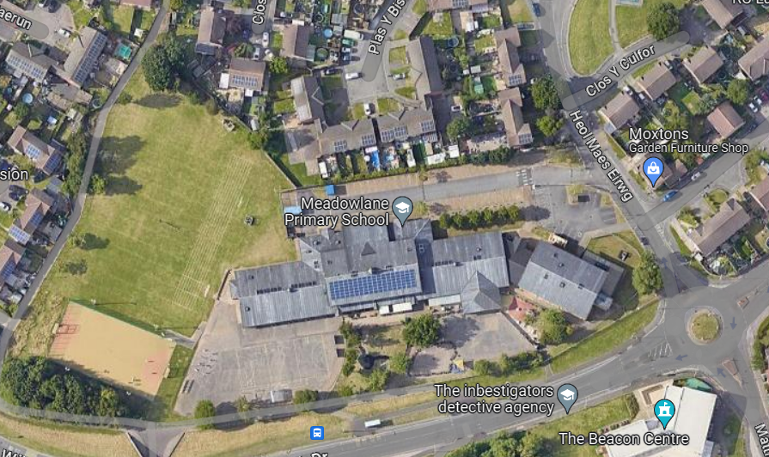

Pedestrian gates

SITE MONITORING FORM:
Used by the schools Senior Leadership Team (SLT) when carrying out traffic management observations. Both good practices and poor practices can be recorded, as well as any incidents. It is important to record traffic management observations as this will provide evidence that the school is monitoring their traffic management arrangements. The schools allocated H&S Officer will be able to support and attend (where possible).
DATE | AREA | OBSERVATIONS | INCIDENTS | SIGNED

